Information Layers and Hierarchies

Game Selected: Grim Fandango

# Overview

Grim Fandango is an adventure game developed and released for PC, PlayStation 4, Android iPad and iPhone. The game is revolutionary in the adventure game genre in which it was the first adventure game to use 3D computer graphics which were overlaid on pre-rendered static backgrounds. The game combines elements of the Aztec belief of the afterlife with Film Noir style.

The game is set in the Land of the Dead, through which recently departed souls (which are represented as Calaca-like figures or skeleton figures) are desperately trying to reach the Ninth Underworld (the land of eternal rest). The game story revolves around the main character Manuel “Manny” Calavera as he attempts to save new arrival Mercedes “Meche” Colomar, a virtuous soul on her journey to the Ninth Underworld.

In the game, the player navigates the player through environments (keyboard and mouse for PC, controller for PS4 and touchpad for tablets/phones) progressing through levels by collecting and using items, solving puzzles, engaging with the various characters in-game and navigating through levels by completing objectives which enable the player to advance through the game.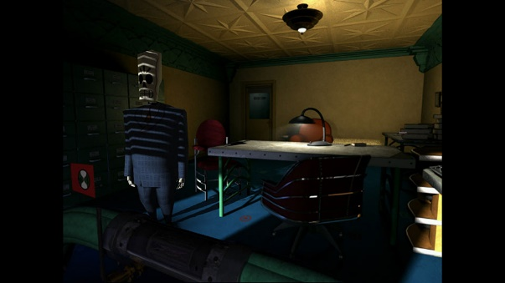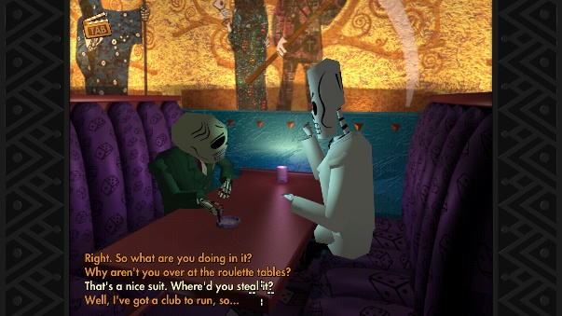

# 

Gameplay link: <https://youtu.be/BnhRQIBfaSM>

# Proposal

The proposed changes to the audio/visual aspect of the game includes a hint system that enables the player to use small hints and suggestions to progress through the game if the player is lost on what to do during the game. The other proposal is an improved inventory system which involves a wheel-based system which allows quicker access to items when the player requires a specific item for a specific task.

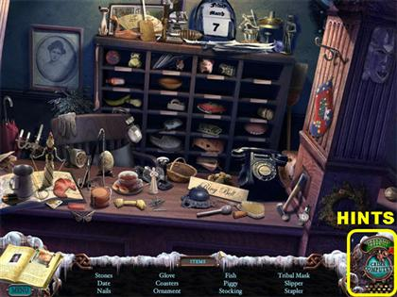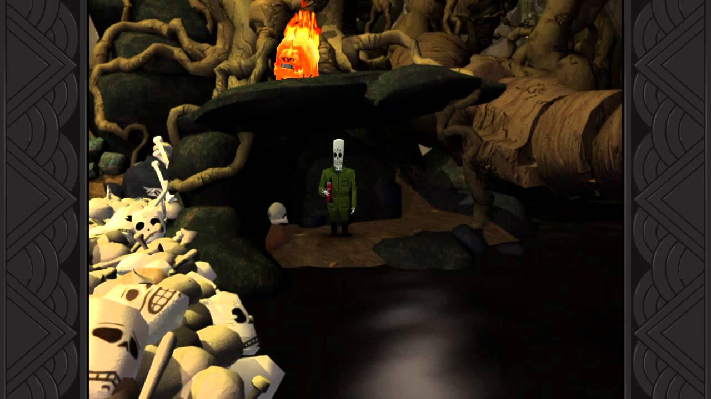

# Reasoning

In Grim Fandango, the game has no form of hint system which enables the player to grasp an idea on what to do next. Because of an absence of a hint system, this results in players spending minutes wandering around the game trying to find out what to do next. This drew criticism from critics, which went on record and said a hint system would’ve been beneficial for the game.  
The way the hint system will work is that a hint button (on-screen or button configured depending on the platform) in which the player will be able to use in which the next thing to use/interact/venture to will be highlighted, or alternatively text prompts will appear to inform the player of a specific thing that they could do.

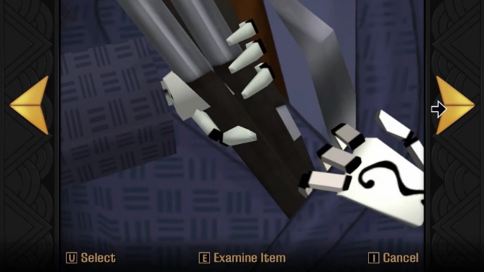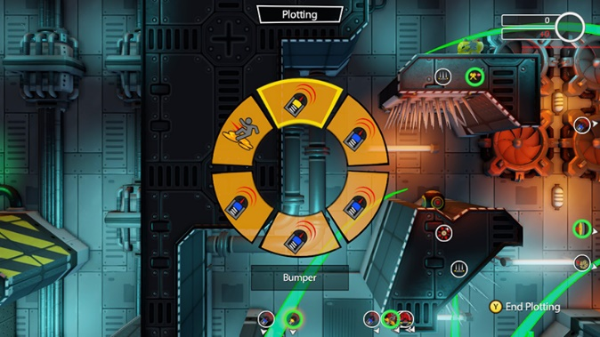

With the inventory system that the game has, it resembles someone reaching into their jacket pocket and pulling something out. The system is a simple left and right cycling method, which in times can result in slow gameplay pacing and frustration in selecting an item that they need.  
The already established inventory will be replaced with a wheel that makes it easier to access items that the player needs. The explanation of items will still be in place, which makes the new system even more practical to use.